PART 1: Exploratory Data Analyses

- Domain Overview:
This project focuses on cricket, specifically the Indian Premier League (IPL), one of the world's most prominent and competitive T20 cricket tournaments. Sports analytics in this domain helps stakeholders make data-driven decisions around strategy, team selection, and performance evaluation.

- Data Source and Reliability:

- Dataset Name: matches.csv
- Cleaned dataset: clean_matches.csv
- Dataset Link: https://www.kaggle.com/datasets/nowke9/ipldata?resource=download
- Source: Kaggle IPL Dataset
- The dataset is reliable, widely used for analytics projects, and reflects real-world match outcomes and events. It is structured, clean, and contains no missing critical fields.
- Then I have performed ETL on matches.csv and saved the updated file as clean_matches.csv and performed analysis on this file(clean_matches.csv).

- Variables Description & Relationships:

Variable | Description
id | Unique identifier of the match
season | IPL season/year
city | City where the match was played
date | Match date
team1, team2 | Competing teams
Toss winner | Team that won the toss
Toss decision | Decision after winning toss (bat/field)
result | Match result type (normal, tie, etc.)
Dl applied | Duckworth-Lewis rule applied (0 or 1)
winner | Match-winning team
Win by runs | Margin of win in runs (if batting first)
Win by wickets | Margin of win in wickets (if chasing)
Player of match | Best player of the match
venue | Stadium name
umpire1, umpire2, umpire3 | Match officials

- Relationships of variables:
- team1, team2, winner, toss winner are closely connected and define outcomes.
- Toss decision impacts win by runs/wickets.
- season is a grouping variable for temporal analysis.
- city, venue influence geographic and stadium-specific trends.

- Problem Statement:
- How do toss decisions, venues, seasonal trends, and match outcomes interact and affect the performance of IPL teams?
- Can we uncover winning patterns and actionable strategies by exploring these interactions?

- Target Audience:
- IPL Coaches and Team Strategists.
- Analysts working with franchises.
- Sports fans and broadcasters.
- Decision-makers in IPL management.

- Expected Actionable Insights:
- Best venues for specific teams.
- Impact of toss decisions on winning.
- Seasonal win patterns.
- Teams with highest winning margins.
- Consistent players and match-winners.

- EXPLORATORY DATA ANALYTICS IN Excel Insights:
- First I have checked for missing Data and I found some columns has missing value such as :- Umpire1,Umpire2 so, I have replaced NULL’s with “No Data” .
- Umpire3 is completely NULL so I have removed that column.
- Winner Column also has missing values so I have filled it with “No Data” as it is a categorical data.
- Player of the match also has missing value, I have added “No Data” to those places.
- Then saved a file with clean_matches.csv name and then connected and loaded it into tableau data source.

- Dashboard’s Creation Steps:

- Dashboard 1: Toss Decision vs Match Outcome.

Created Sheet 1: Toss Decision Outcome Analysis

  - Created two calculated fields ‘Toss win match win?’ and ‘Toss decision outcome’.

[Toss Win Match Win? = IF [toss winner] = [winner] THEN "Yes" ELSE "No" END]

[Toss Decision Outcome = [toss decision] + " - " + [Toss Win Match Win?]]

  - Includes variables: Toss Decision Outcome(Column) and count[id] in Rows.
  - Created filter ‘Season’ and ‘Toss Winner’.

Created Sheet 2: Toss Decision Win Rate %

  - Dragged Toss Decision to column and Toss Win Match Win to Row.
  - Moved count(id) to text and created quick table calculation and set it to percent of total and set it to table(across).

- Dashboard 1 Insights:

• How toss decision correlates with actual match results
• Whether batting or fielding after toss is more likely to lead to a win
• Over different seasons or teams
Dashboard 1 Screenshot:

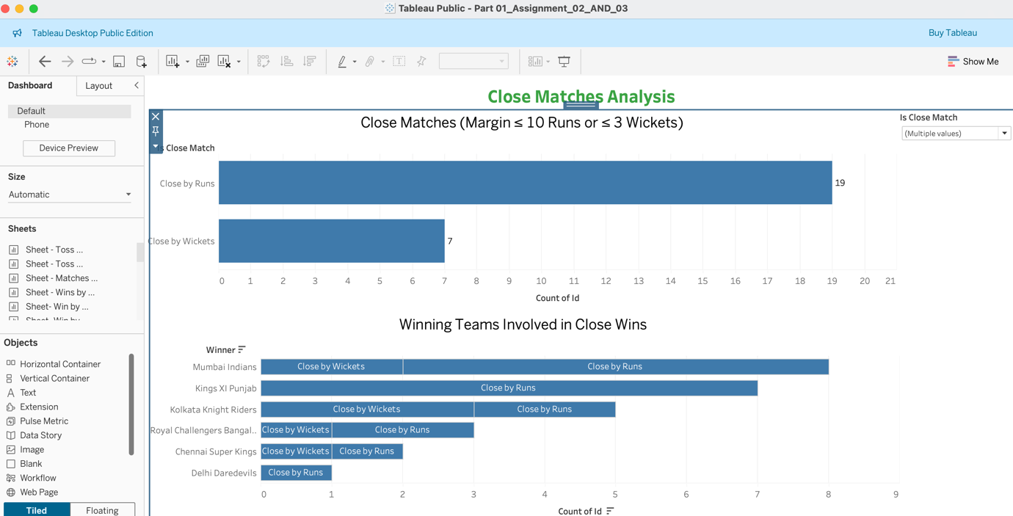

- Dashboard 2: Venue Performance

Created sheet 1: Matches Played per Stadium

- Added top 10 Venue to Row and count(id) to column.
- Sort count(id) to descending.
- Created and use season and venue filter.
- Used horizontal bar chart for visualisation.

Created sheet 2: Wins by Team in Each Venue

- Duplicate the sheet 1.
- Added winner with count(id) in Rows.
- Added venue to the column.
- Added winner to the colour.
- And again used season as filter.
- Visualise this sheet on stacked bar chart.

Dashboard 2 Screenshot:

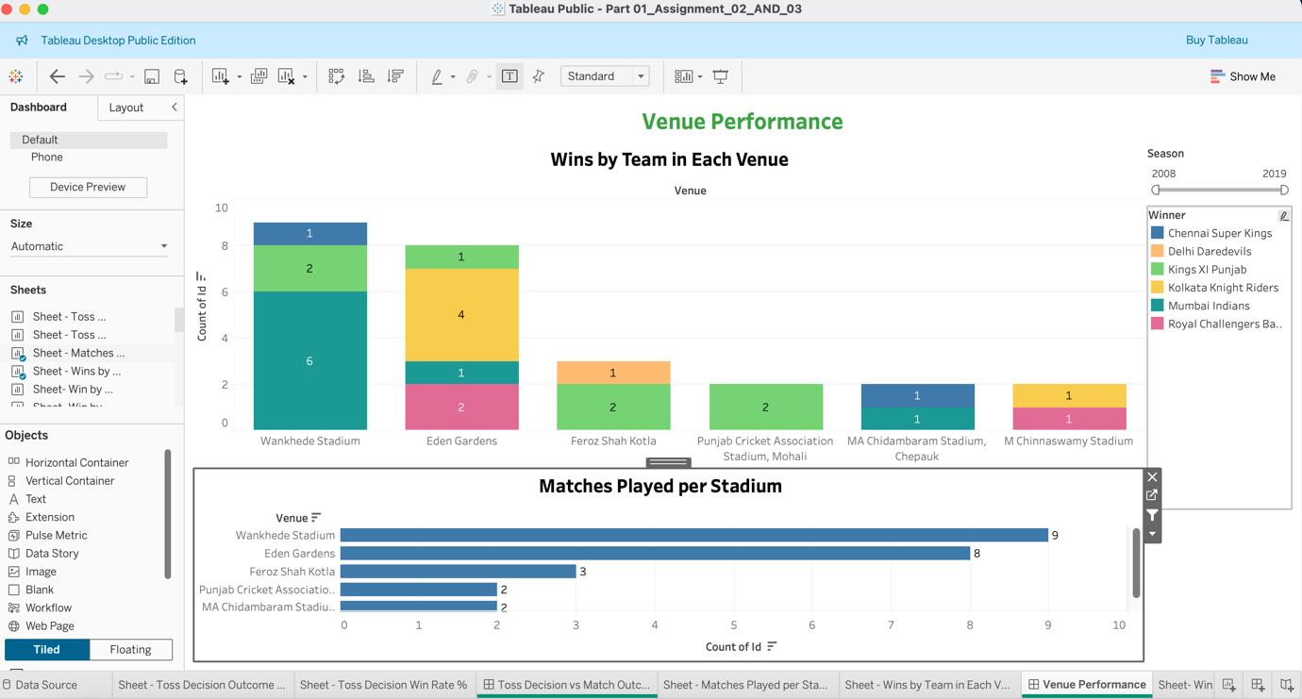

- Dashboard 3: Win Margins Analysis

Created sheet 1: Win by Runs Distribution

- Selected win by runs in column.
- Count(id) in rows.
- Visualize this on the line graph.
- Created season and winner filter to make this interactive.

Created sheet 2: Win by Wickets Distribution

- Take win by wickets in column.
- Count(id) in rows.
- Used line graph for visualization.

Dashboard 3 Screenshot:

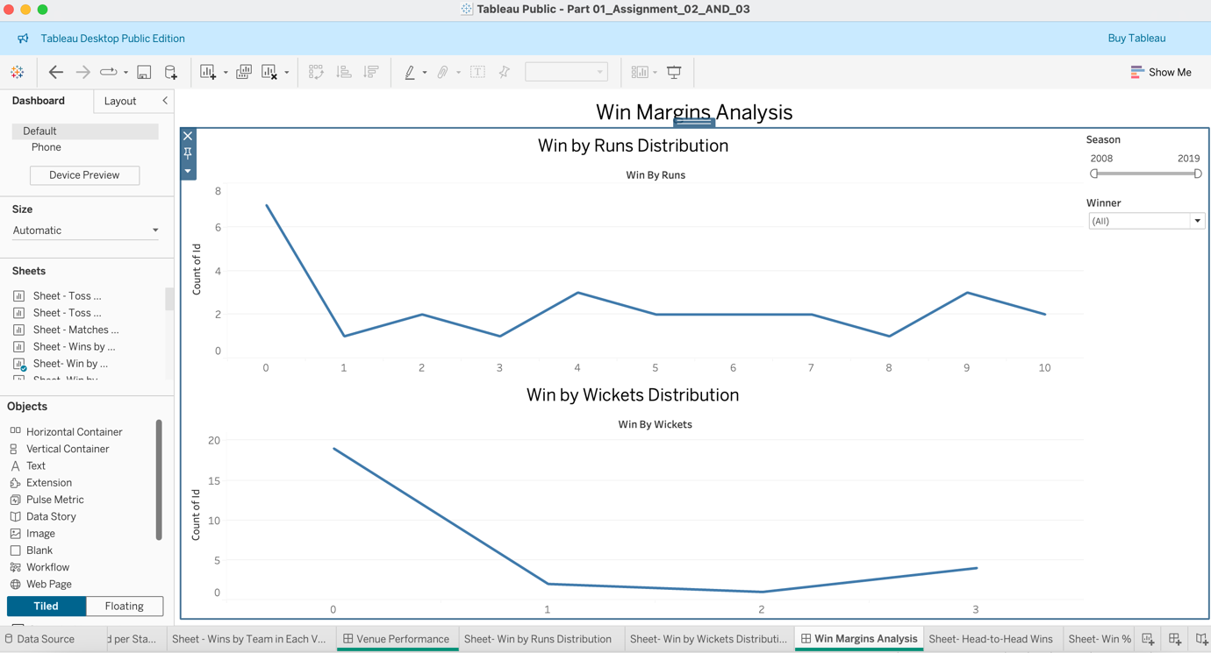

- Dashboard 4: Team Rivalries

“Goal: Compare win counts between specific teams”

Created sheet 2: Head-to-Head Wins

- Created new calculated field “Matchup”.
[IF team1 < team2 THEN team1 + " vs " + team2 ELSE team2 + " vs " + team1]
- Drag matchup and winner to columns..
- matchup to colour.
- Take count(id) to rows.
- Added season as filter.
- Used side by side bar for visualization.

Created Sheet 2: Win % in Rivalries

- Take count(id) in columns.
- And matchup in rows.
- Created a quick field on count(id) as percentage by total and used calculation as table(across).
- Changed the visual to Stacked Bar Chart.
- Added season and winner for filter controls on dashboard.

Dashboard 4 Screenshot:

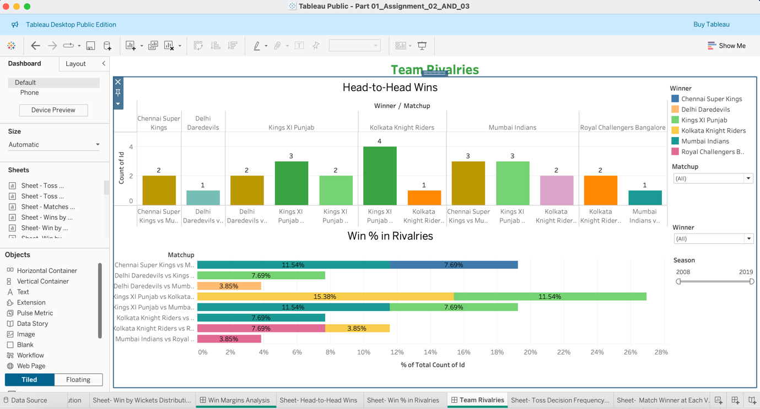

- Dashboard 5: Toss Decision Impact by Venue on Match Win

“Goal: How does toss decision affect outcomes at specific venues?

Created Sheet 1: Toss Decision Frequency by Venue

- Take venue to the rows.
- Dragged Toss Decision to colour.
- Dragged Id to column and take the measure as count.
- Added season as filter.
- Selected stacked bar chart for visual.

Created Sheet 2: Match Winner at Each Venue

- Duplicate the sheet 1.
- Replaced winner to Toss Decision.
- Change venue from rows to columns.
- Added winner to column as well.
- Added venue and season to filters.
- Used side by side bar chart for visualization.

Dashboard 5 Screenshot:

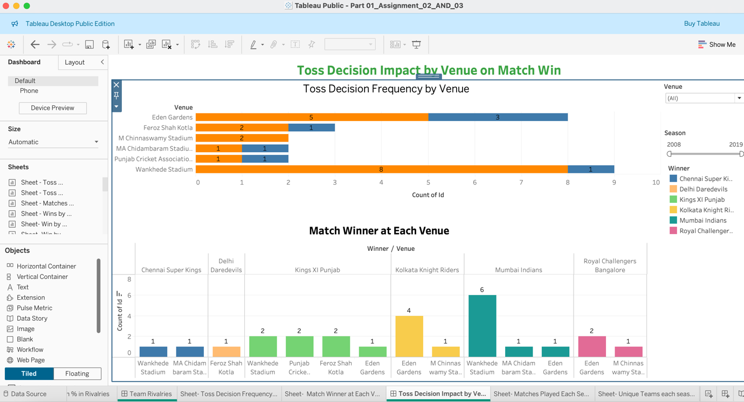

Dashboard 6: Season-Wise Match Summary

“Goal: Provide a season-by-season view of how the number of matches and teams evolved over time.”

Created Sheet 1: Matches Played Each Season

- Take Season to columns and as it is a numeric data so I have convert it to dimension.
- Count(id) to rows.
- Added season as filter.
- Used line chart to visualize how many matches played in each season.

Created Sheet 2: Unique Teams Each Season

- Took distinct count “countd(team1)” from the dataset to rows.
- Dragged “season” to column.
- Take “Teams” to rows.
- Added “season” as filter.
- Visualize it on line chart.

Dashboard 6 Screenshot:

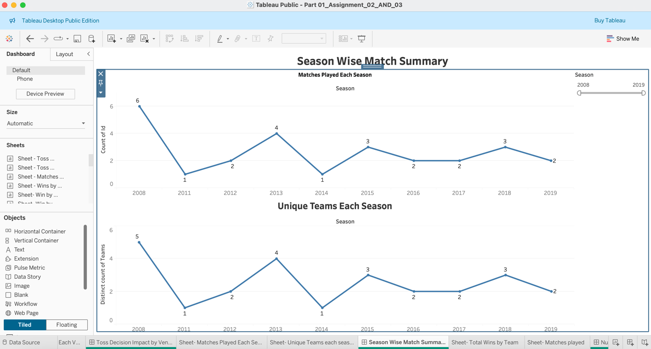

- Dashboard 7: Number of Winning in all seasons

“Goal: Show which teams have the most match wins over all seasons.”

Created Sheet 1: Total Wins by Team

- Dragged count(id) in Columns.
- And Winner in Rows.
- Which shows total matches won by a team.
- Added winner as filter to see data about specific team.

Created Sheet 2: Match Played

- Take the season in Columns and set the replace measure with dimension.
- Dragged count(id) to the Rows.[to show total matches played by the teams].
- Add season as filter.

Dashboard 7 Screenshot:

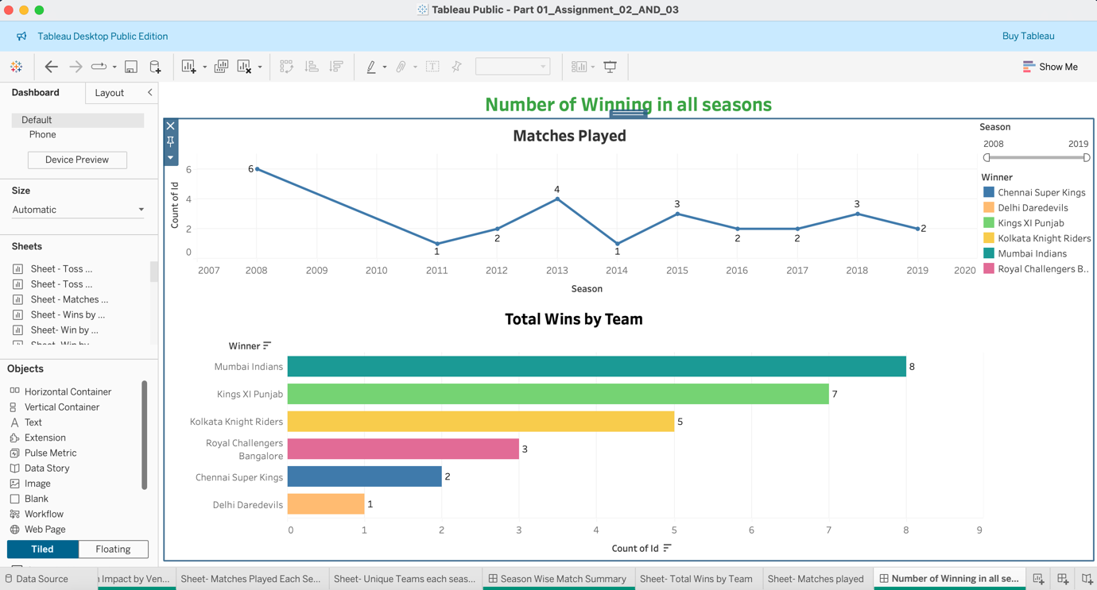

- Dashboard 8: Matches by City & Venue

“Goal: Understand match distribution across cities and venues.

Created Sheet 1: Matches by City

- Took “City” in Rows.
- And “count(ID)” in columns.
- Added season as filter.

Created Sheet 2: Matches by Venue

- Duplicate the sheet 1.
- And replace “City” with “Venue”.
- Visualize these sheets on Pie chart to see the number of matches played in which city and at which stadium.

Dashboard 8 screenshot:

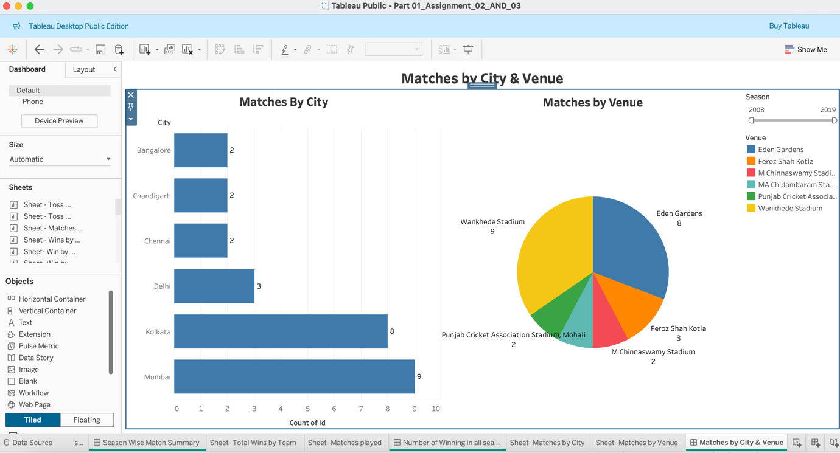

- Dashboard 9: Toss Decision Patterns Over Seasons

“Goal: Helps coaches analyse decision strategies across seasons.”

Created Sheet 1: Toss Decisions per Season

- Take “season” variable to column.
- And dragged “Toss Decision” to colour.
- Take “count(ID)” to rows.
- Added season as filter.
- Visualize this on line graph to that shows in how many matches toss winning team has chosen Batting or Fielding.

Created Sheet 2: Toss Winners per Season

- Kept the column variable same as sheet 1 (season).
- Dragged “Toss Winner” to the colour.
- And “count(ID)” to the rows.
- Visualize this on Ghant chart that shows which team won the toss in which season.

Dashboard 9 screenshot:

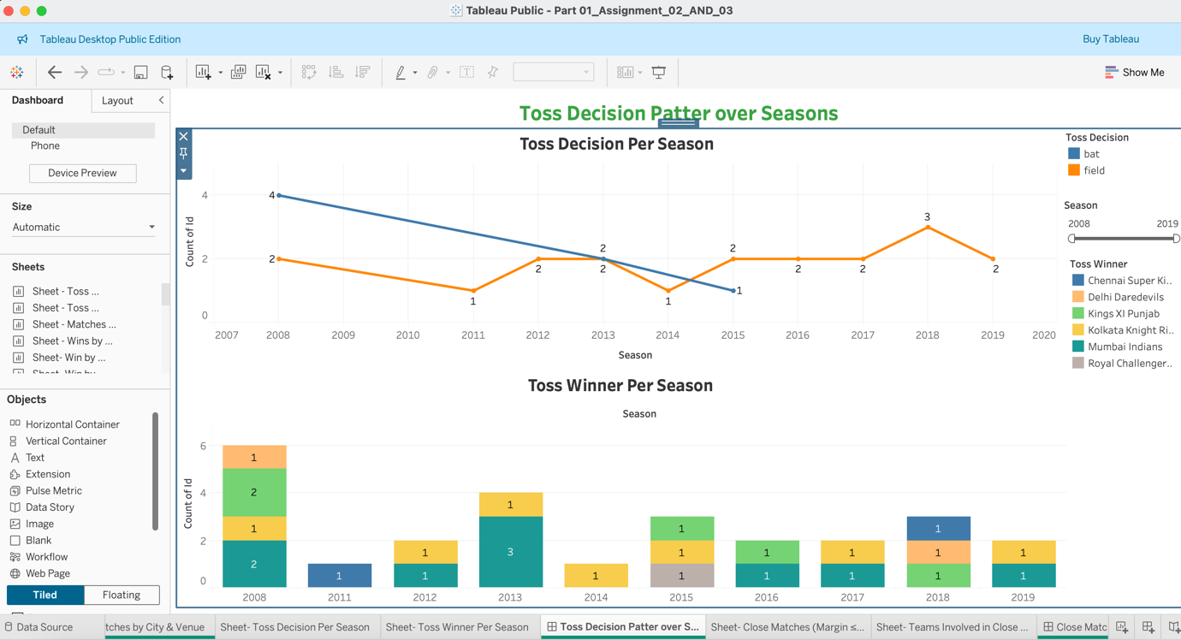

- Dashboard 10: Close Matches Analysis

“Goal: To see that does "bat" or "field" give better results after toss?

Created Sheet 1: Close Matches (Margin ≤ 10 Runs or ≤ 3 Wickets)

- Drag count(id) to column.
- Create a calculated field to identify close matches: Is Close Match: [IF [win by runs] <= 10 AND [win by runs] > 0 THEN "Close by Runs"
ELSEIF [win by wickets] <= 3 AND [win by wickets] > 0 THEN "Close by Wickets"
ELSE "Other"
END]
- Dragged Is Close Match in Rows and in Filters.
- Used Close win by run and Close win by Wickets.

Created Sheet 2: Teams Involved in Close Wins

- Drag winner to Rows.
- Drag count(id) to Columns.
- Drag the Is Close Match calculated field to Filters:
Select only: Close by Runs, Close by Wickets.
- Drag Is Close Match to Label to differentiate easily.
- Sort the chart descending by the number of close wins.

Dashboard 10 Screenshot:

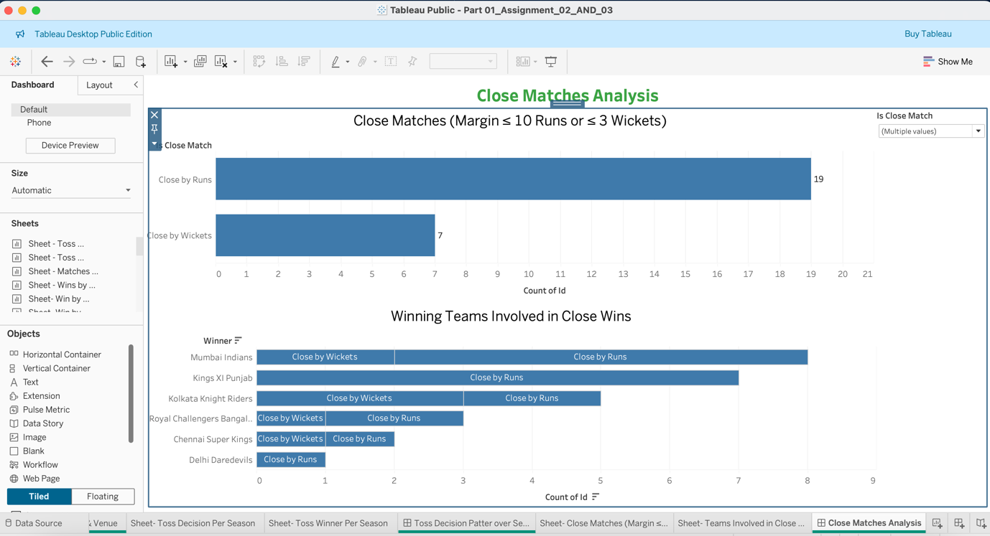

Detailed Description of Dashboards:

- Dashboard 1: Toss Decision vs. Match Outcome

- Target Audience:
Cricket analysts, team coaches, and broadcast storytellers who are interested in match tension and clutch performance.

- Purpose & Information Presented:
This dashboard highlights closely fought matches, both by runs and wickets.

It identifies teams that consistently win tight games, reflecting performance under pressure.

- Actionable Insights & Decisions:
Analysts can focus on teams with high pressure-handling capabilities.

Coaches can use this insight to build game strategies and evaluate players suited for crunch scenarios.

Broadcasters can highlight such patterns in pre/post-match analysis to boost viewer engagement.

- Decision-Making Impact:
Teams might review tactical decisions from close games.

Management may use it for squad selections or identify clutch performers.

Data storytelling teams can use it for fan engagement and social media content.

- Dashboard 2: Venue Performance

Target Audience: IPL organizers, operations managers, and strategic planners.

Purpose: To analyse the match distribution and team performance at different stadiums/venues.

Information Presented:

Sheet 1: A horizontal bar chart showing the total number of matches played at each venue.

Sheet 2: A stacked bar chart illustrating the wins per venue, broken out by winning teams.

Actionable Insights & Decisions:

Insight: Identify which venues are high-performing and which have tightly contested outcomes.

Action: Optimize scheduling, consider venue-specific strategies, and determine the best venues for marquee matchups.

Beneficiaries: League organizers, operations managers, and team strategists.

- Dashboard 3: Toss Winners vs. Match Winners

Target Audience: Analysts, broadcasters, and team management.

Purpose: To compare the frequency of teams winning the toss with the overall match-winning record.

Information Presented:

Sheet 1: A bar chart displaying the count of toss wins by each team.

Sheet 2: A similar bar chart showing match wins by team.

Actionable Insights & Decisions:

Insight: Recognize if teams that win the toss are also more successful overall.

Action: Adjust in-match strategies and highlight which teams leverage toss advantage effectively.

Beneficiaries: Broadcast teams, tactical coaches, and decision-makers.

- Dashboard 4: Team Rivalries & Head-to-Head Analysis

Target Audience: Sports analysts, team strategists, and commentators.

Purpose: To reveal the head-to-head performance between teams and highlight competitive rivalries.

Information Presented:

Sheet 1: A side-by-side bar chart that visualizes head-to-head win counts (using a calculated “matchup” field).

Sheet 2: A stacked bar chart illustrating the win percentage in each rivalry.

Actionable Insights & Decisions:

Insight: Understand how teams perform against traditional rivals.

Action: Use this information for refined match preparation and to build engaging narratives for viewers.

Beneficiaries: Coaching staff, broadcast analysts, and league strategists.

- Dashboard 5: Toss vs. Venue Influence

Target Audience: Tactical coaches and operations personnel.

Purpose: To assess if the venue modifies the impact of toss decisions on match outcomes.

Information Presented:

Sheet 1: A stacked bar chart of toss decision frequencies across venues.

Sheet 2: A complementary bar chart showing the match winners at these venues.

Actionable Insights & Decisions:

Insight: Determine if certain venues favour a particular toss decision outcome.

Action: Tailor tactics and make informed decisions on team strategies when playing at different venues.

Beneficiaries: Team strategists and game planners.

- Dashboard 6: Season-Wise Match Summary

Target Audience: League administrators, analysts, and team management.

Purpose: To provide a seasonal view of overall match activity and to track league growth.

Information Presented:

Sheet 1: A line chart showing the total number of matches played in each season.

Sheet 2: An area (or line) chart displaying the number of unique teams (or average wins) each season.

Actionable Insights & Decisions:

Insight: Observe seasonal trends, fluctuations in match volume, and league expansion.

Action: Inform scheduling, marketing strategies, and developmental policies based on historical data.

Beneficiaries: League officials, marketing teams, and operational executives.

- Dashboard 7: Top Performing Teams

Target Audience: Fans, broadcasters, and team managers.

Purpose: To rank teams by performance metrics (matches won) over various seasons.

Information Presented:

Sheet 1: A horizontal bar chart showing total wins by each team.

Sheet 2: (Optional) A complementary view—such as a dual-axis chart—that overlays win percentage or win margin.

Actionable Insights & Decisions:

Insight: Identify consistently high-performing teams.

Action: Use this data for fan engagement, sponsorship negotiations, and performance benchmarking.

Beneficiaries: Team management, broadcasters, and sponsor groups.

- Dashboard 8: Matches by City & Venue

Target Audience: IPL organizers, venue managers, and city event planners.

Purpose: To visualize match distribution geographically, showing which cities/venues host the most games.

Information Presented:

Sheet 1: A bar or map view of matches by city.

Sheet 2: A similar view focusing on the venue.

Actionable Insights & Decisions:

Insight: Determine the most popular locations and identify opportunities for new markets or better scheduling.

Action: Optimize match scheduling, venue maintenance strategies, and regional marketing initiatives.

Beneficiaries: IPL organizers, local authorities, and venue managers.

- Dashboard 9: Toss Decision Patterns Over Seasons

Target Audience: Coaches, analysts, and tournament statisticians.

Purpose: To examine how toss decisions have evolved through seasons.

Information Presented:

Sheet 1: A stacked bar chart of toss decisions (bat/field) by season.

Sheet 2: A complementary chart depicting toss winner trends by season.

Actionable Insights & Decisions:

Insight: Reveal any significant changes in toss decision preferences or their effectiveness over time.

Action: Use the trends to optimize pre-match strategies and to forecast future game dynamics.

Beneficiaries: Coaching staff, match analysts, and league statisticians.

- Dashboard 10: Match Outcome Based on Toss Decision

Target Audience: Team captains, strategic planners, and performance analysts.

Purpose: To directly correlate toss decisions (bat/field) with subsequent match outcomes.

Information Presented:

Sheet 1: A bar chart (with a table calculation for percent of total) showing the proportion of matches where the toss-winning team went on to win.

Sheet 2: A heatmap or cross-tab that displays the relationship between toss winner and match winner.

Actionable Insights & Decisions:

Insight: Clarify if there is a measurable benefit to choosing a specific toss decision.

Action: Inform in-game decisions (such as whether to bat or field) and help adjust team strategies accordingly.

Beneficiaries: Captains, in-match coaches, and tactical analysts.

